**Lab-Tasks**

Complete all the Lab Tasks Given in Lab Manuals

**Home-Taks**

**ROWNUM** -> used to get first n rows from a given table.

Example:   
**select * from employees where rownum <= 10;** (return first 10 rows)

**Mathematical Operations**

Just like any other language, you can perform mathematical

operations in SQL by writing expressions after the **SELECT** command,

you can also perform mathematical operations after the **WHERE**

clause (will tell you about this in detail when we are discussing sub

queries)

Examples:

**Select * from employees where salary between 100 * 1.5 and 10000 + 500;**

**Select salary * 1.5 as "increment" from employees;**

**Select salary * commission_pct as "increment" from employees**

**where commission_pct is not null;**

**Tasks:**

1 – Fetch the bottom 10 values from the employees table w.r.t to employee ID.

2 – List the departments with the most employees from top to bottom (department ID can’t be NULL).

3 - Display the employee number, name, salary of employee before and after 15% increment. Name the calculated new salary as “Incremented Salary” and calculate the difference between two salaries. Name the increased amount to be “Incremented Amount”. Output preview below…

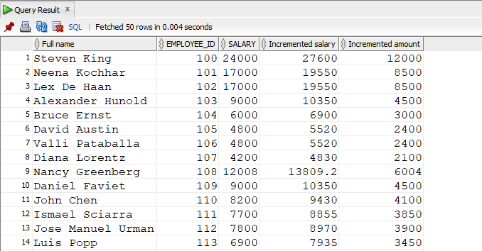

**4 -** Display the department and manager id wise avg commission for all employees. Round the commission up to 2 decimals, filter any null. values.  
Sample Output…

